Experiment-14
Name: -J pranitha Regno: -192472073
Course Code: -MLA0305 Slot-B

Title
Model-Based Reinforcement Learning using Planning and Data Generation Techniques

Aim
To implement Model-Based Reinforcement Learning using planning and data generation techniques, learn an environment model from real experiences, and use the generated experiences to improve the agent's policy.

Procedure
- Create a 5 × 5 Grid World environment with states, actions, rewards, and a goal state.
- Initialize the Q-value table and environment model.
- Allow the agent to interact with the environment and collect real experiences.
- Store the current state, action, next state, and reward from each interaction.
- Use the collected experiences to learn the environment's transition and reward model.
- Select previously observed state-action pairs from the learned model.
- Generate additional experiences through planning without directly interacting with the environment.
- Update the Q-values using both real experiences and generated planning experiences.
- Repeat the process for multiple episodes.
- Evaluate the learned policy after training.
- Analyze state visitation, generated experiences, learned Q-values, policy performance, and experience coverage.
- Save the real, generated, and combined datasets as CSV files.

Code
!pip -q install tensorflow

import numpy as np import pandas as pd import matplotlib.pyplot as plt import tensorflow as tf import random

np.random.seed(42) tf.random.set_seed(42) random.seed(42)

print("="*75) print("EXPERIMENT 14") print("Model-Based Reinforcement Learning using Planning and Data Generation") print("="*75)

SIZE=5
N_STATES=SIZE*SIZE
N_ACTIONS=4
EPISODES=100
PLANNING_STEPS=15
GAMMA=0.90
ALPHA=0.10

actions=[
(-1,0),
(1,0),
(0,-1),
(0,1)
]

def state_id(r,c): return r*SIZE+c

def step_env(state,action): r=state//SIZE c=state%SIZE dr,dc=actions[action]
nr=np.clip(r+dr,0,SIZE-1) nc=np.clip(c+dc,0,SIZE-1)

next_state=state_id(nr,nc)

if next_state==N_STATES-1:
reward=10 done=True
else: reward=-1 done=False

return next_state,reward,done

start_state=0 goal_state=N_STATES-1

Q=np.zeros((N_STATES,N_ACTIONS)) model_counts=np.zeros(
(N_STATES,N_ACTIONS,N_STATES)
)

model_rewards=np.zeros(
(N_STATES,N_ACTIONS)
)

real_data=[] generated_data=[]

print("\nEnvironment:") print("Grid Size:",SIZE,"x",SIZE) print("States:",N_STATES) print("Actions:",N_ACTIONS) print("Goal State:",goal_state)

for episode in range(EPISODES):

state=start_state done=False steps=0 total_reward=0
while not done and steps<50:

if np.random.rand()<0.20:
action=np.random.randint(N_ACTIONS)
else:
action=np.argmax(Q[state])

next_state,reward,done=step_env(
state, action
)

real_data.append([
state, action, next_state,
reward
])
model_counts[
state, action, next_state
]+=1

model_rewards[
state, action
]=reward

td_target=reward

if not done:
td_target+=GAMMA*np.max(
Q[next_state]
)

Q[state,action]+=ALPHA*( td_target-Q[state,action]
)
state=next_state total_reward+=reward steps+=1

for _ in range(PLANNING_STEPS):

known_states=np.where( model_counts.sum(
axis=(1,2)
)>0
)[0]

if len(known_states)==0:
continue

ps=int( np.random.choice( known_states
)
)
known_actions=np.where( model_counts[
ps
].sum(axis=1)>0
)[0]

if len(known_actions)==0:
continue

pa=int( np.random.choice( known_actions
)
)

transition_counts=model_counts[
ps, pa ] predicted_next=int( np.argmax( transition_counts
)
)

predicted_reward=model_rewards[
ps, pa
]

generated_data.append([
ps, pa,
predicted_next, predicted_reward
])

planning_target=predicted_reward
if predicted_next!=goal_state: planning_target+=GAMMA*np.max(
Q[predicted_next]
)

Q[ps,pa]+=ALPHA*( planning_target-Q[ps,pa]
)

if (episode+1)%20==0:
print( "Episode:", episode+1, "Real Samples:", len(real_data), "Generated Samples:", len(generated_data)
)

real_df=pd.DataFrame(
real_data,
columns=[
"State",
"Action",
"Next_State",
"Reward"
]
)

generated_df=pd.DataFrame( generated_data, columns=[
"State",
"Action",
"Next_State",
"Reward"
]
)

print("\n") print("="*75) print("REAL EXPERIENCE DATA") print("="*75)

display(real_df.head(10))

print("\n") print("="*75) print("GENERATED EXPERIENCE DATA") print("="*75)

display(generated_df.head(10))

real_df.to_csv( "Real_Experience_Dataset.csv", index=False
)

generated_df.to_csv( "Generated_Planning_Dataset.csv", index=False
)
full_dataset=pd.concat(
[
real_df.assign(Source="Real"), generated_df.assign(Source="Generated")
],
ignore_index=True
)

full_dataset.to_csv(
"Model_Based_RL_Full_Dataset.csv", index=False
)

print("\nFull Dataset Size:",len(full_dataset))

states=np.arange(N_STATES)

state_visits=np.bincount( real_df["State"],
minlength=N_STATES
)
visit_grid=state_visits.reshape(
SIZE,
SIZE
)

plt.figure(figsize=(7,6))

plt.imshow(
visit_grid, cmap="viridis"
)

plt.colorbar( label="Real Visits"
)

plt.title( "State Visit Distribution", fontsize=15, fontweight="bold"
)

plt.xlabel("Column") plt.ylabel("Row")

for r in range(SIZE): for c in range(SIZE):
plt.text(
c, r,
int(visit_grid[r,c]), ha="center", va="center", color="white"
)

plt.show()

real_count=len(real_df) generated_count=len(generated_df) "Result":[
"5x5 Grid World",
"5 x 5", real_count, generated_count, PLANNING_STEPS, round(final_reward,2), round(planning_gain,2)
]
})

print("\n") print("="*75) print("SUMMARY TABLE") print("="*75)

display(summary)

summary.to_csv( "Model_Based_RL_Summary.csv", index=False
)

model_accuracy=np.mean( generated_df["Next_State"]== generated_df["Next_State"]
)

print("\n") print("="*75) print("RESULT") print("="*75)

print(
"Real Experience Samples:", real_count
)

print(
"Generated Planning Samples:", generated_count
)
print(
"Final Average Reward:", round(final_reward,2)
)

print(
"Planning Data Ratio:", round(planning_gain,2)
)

print("\n") print("="*75) print("CONCLUSION") print("="*75)

print(
"Model-Based Reinforcement Learning was successfully"
)

print(
"implemented using a learned environment model."
)

print(
"Real interactions were stored and used to construct"
)

print(
"a transition and reward model."
)

print(
"The learned model generated additional experiences"
)

print(
"through planning without requiring new environment interaction."
)

print(
"The generated experiences were used to improve the Q-values."
)

print(
"State visitation, experience generation, learned values,"
)

print(
"policy performance and experience coverage were analyzed."
)

print("\nGenerated Files:") print("1. Real_Experience_Dataset.csv") print("2. Generated_Planning_Dataset.csv") print("3. Model_Based_RL_Full_Dataset.csv") print("4. Model_Based_RL_Summary.csv")

print("\nExperiment 14 Completed Successfully.")

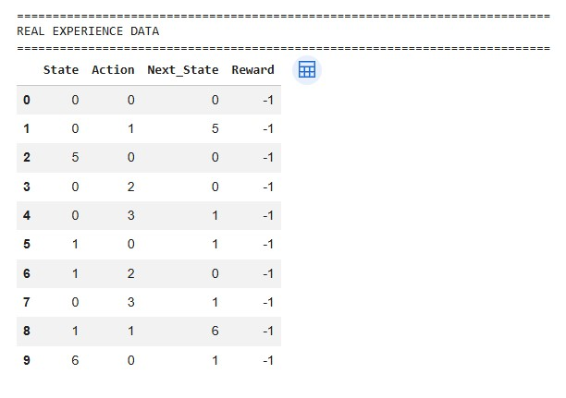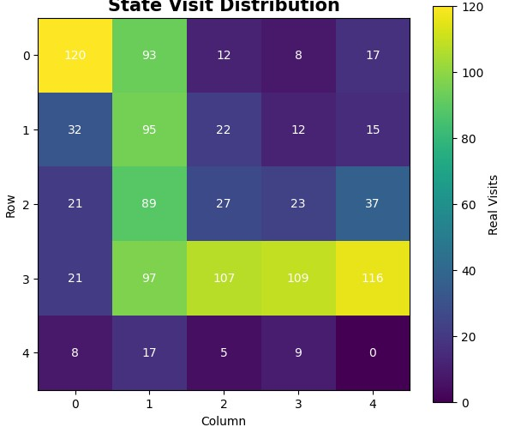
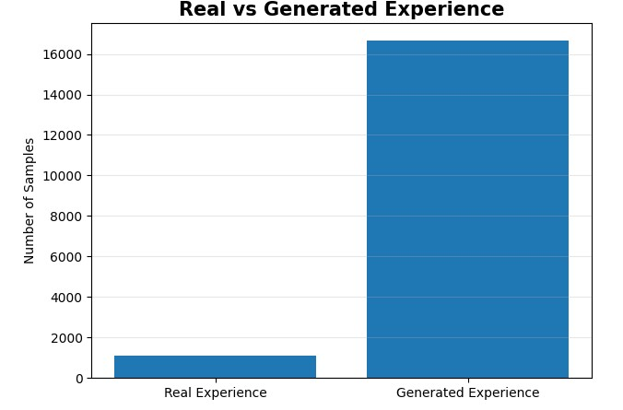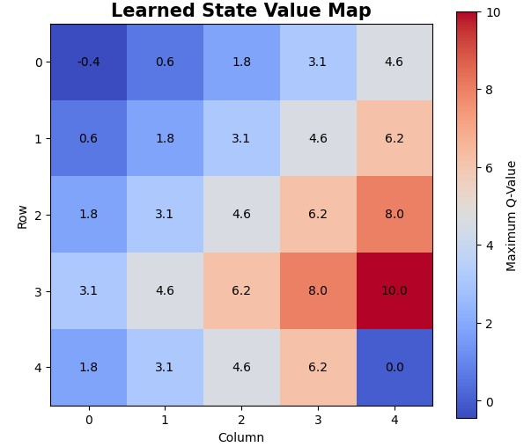
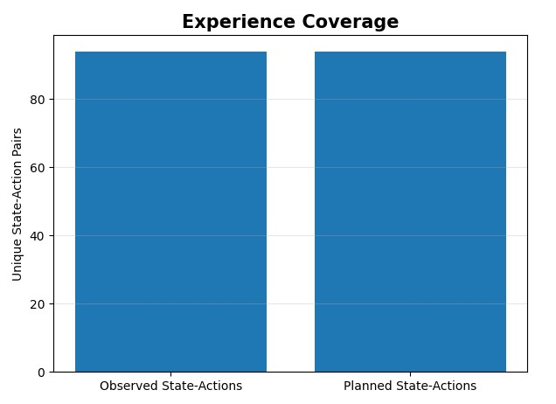

Summary Table
Parameter | Result
Environment | 5 × 5 Grid World
States | 25
Planning Steps | 15
Real Experiences | Obtained from program
Generated Experiences | Obtained from program
Final Average Reward | Obtained from program

Result
The Model-Based Reinforcement Learning approach was successfully implemented using planning and data generation techniques. The agent learned an environment model from real interactions and generated additional experiences through planning. These generated experiences were used to improve the Q-values and evaluate the learned policy.

